Mark Park

i. General

Mark Park is located on the rising ground on the west side of Glen Fyne about a mile or more upstream from the head of the loch. The house plot is bounded on its south side by a large burn, the Merk burn, that runs down to the river. The house itself is located on increasingly steeply rising ground and is partly terraced back into the hillside. The original cottage part was placed not for the views, but to gain maximum daylight, even during the winter months. The importance of the location was that it was not overshadowed by the hillside. The original layout of the cottages appears to be similar to Inverchorachan, further up Glen Fyne, but lacking the wings.

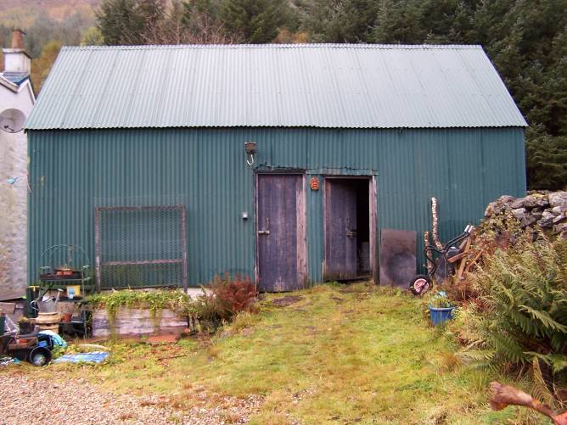
The house is accessed by an estate road that runs along the west side of the River Fyne from which a small access road branches to the west, running up to the north-east area of the house where there is a small drive and yard.
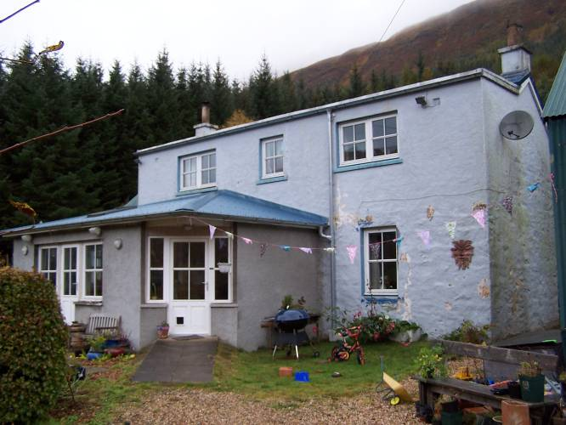

Figure 15 and 16 – East elevation of cottage with modern extension to S and the raised upper storey visible in the fabric change (left), late 19th / early 20th century timber-framed outbuilding (right).

Immediately to the north-east of the main house is an outbuilding which may be of late 19th century or early 20th century date. This is built upon a stone base but is of timber post construction above and the posts extend from sockets within the base up to the wallhead. Internally the roof is of simple A-frame construction. There is one internal dividing wall that is post-built and boarded, partly open. In the east elevation there are paired entrances that correspond to either side of this internal partition. The two entrances to this structure are accessed by means of a stone built ramp up from the east. The two boarded doors of the outbuilding don’t appear to be the originals. Internally it is clear that this had been partly a byre and possibly partly a barn. The floors internally are cobbled of which some parts are visible. The compartment to the north contains a stone-lined drain. This is slightly offset to the south. On the north side of this there is enough space to allow for two or three byres.

Mark Park started life as a smaller estate cottage of three bays and single storey under a double-pitched roof, gabled to north and south whose principal elevation faces east. This original building was rubble-built with a central entrance and a single window on either side on the east elevation. The earliest record appears to be dating to 1889 / 1890 and the name of the house derived from the Merkland walls built around the improved lands.

However, the structure has been substantially extended in three major episodes. The first was the addition of a further bay against the south gable wall. This is rendered externally and is under a crinkly tin roof that is double-pitched. This extension was added in the late 1950s or early 1960s.

The second episode of alterations was a general raising of the original cottage itself whereby an additional metre or so was added to the wallheads and the gables were raised, apparently in the late 1960s. This added a metre to the wallheads to the rear, i.e. to the west. On the principal elevation to the east the walls were raised to a full further storey under a very slightly sloping, almost flat, roof. This added storey appears to have been built in cement blockwork and is rendered externally with a coarse texture to suggest the character of the stonework of the original building below.
The upper level to the east elevation contains three windows, symmetrically arranged, a smaller central window and broader windows on either side.

The house was drawn in around 2000, before the most recent extensions were added by Peter Sumsion, Danny’s Dad.

The third episode of extension occurred in recent years, about 2005, undertaken by Danny Sumsion, who lives in the house today with his family. The construction work was done by John MacDonald and Ferguson’s of Strachur, but Danny did all the interior work himself. The works added a porch and a kitchen extension to the principal elevation to the east and a two storey rear extension. The east extension is of single storey, under a crinkly tin roof that is hipped to either side. It is blockwork-built and rendered externally in cement. The principal external entrance leading to the hall area lies at the north-east corner of this and the entrance is set across the corner at 45°. It contains an entrance doorway with flanking windows. In the main part of its east wall, further south, lighting the kitchen, is a further broad window and door arrangement. A door with sash-and- case windows on either side is separated from the door by a vertical mullion.
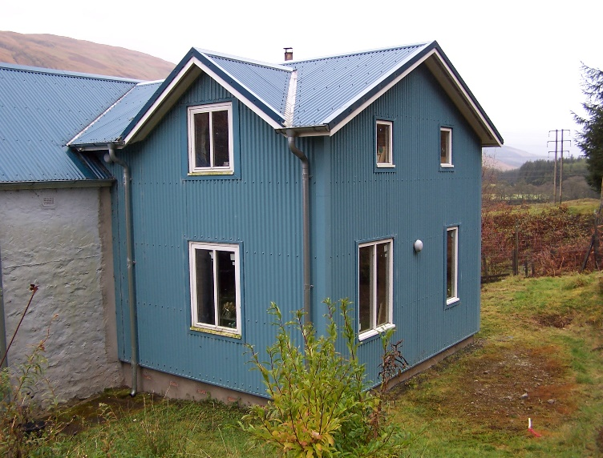
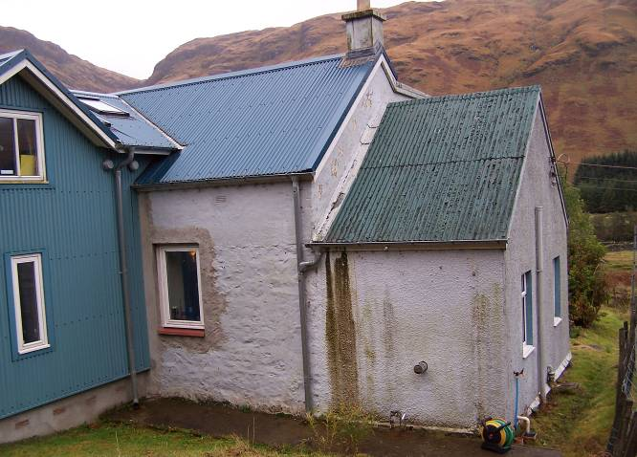

Figure 17 and 18 – 1950s/60s extension to S of main cottage from W (left),
2005 rear extension from NW (right).

ii. External elevations

The original cottage is rubble-built and its quoining appears to be of large slabs, rough-hewn to form the angles. The window openings appear to have been formed of similar stones and only the lintels are more formally tooled. The original wall finish is visible where the early walls are exposed and this appears to have been flush pointed. Over this are visible multiple layers of limewash, the earliest of which is of a pink hue with multiple layers of cream over that (or yellowish cream) and ultimately the existing exterior paint of a pale bluish grey. The original window openings of which the only one that is visible now is that at the north end of the east elevation had been picked out with a blue painted surround.

At the north end of the rear elevation, the west elevation, there is a slight fillet indicating the former presence of an external lean-to construction. The large extension to the rear is on a concrete and cement rendered base. This is one bay deep and two bays wide and is clad in crinkly tin, painted a teal blue. Its crinkly tin roof is of low pitch. This is gabled to the west and there are small gablets above the windows to the north and south at first floor level.

iii. Interior

The entrance to the main house is accessed by a path of pre-cast cement flags. The main entrance gives into a small hall-area-cum-bootroom and this leads eastwards into the original front entrance of the early cottage. The new kitchen extension is accessed from the original house through an entrance formed on the site of one of the early cottage windows. This has been broadened out and lined with window panelling brought in from a flat in Glasgow. Within the original entrance to the house, this gave way to a small vestibule. This is lined out with 3” tongue-and-grooved v-section matchboarding which lines the walls and the ceiling. The original boarding still survived on either side of the entrance and on the walls to the east/north and south and upon the ceiling. The doors within the original entrance were paired storm doors, now since removed. The entrances into the vestibule are detailed with moulded architraves with a narrow roll to the inner angle and a cyma moulding externally. There is a small, applied moulding at picture rail level and a further cornice moulding which is of cyma profile. This vestibule originally gave into the principal rooms to the north and south. Of these, the northern room is very much of its original detail, in spite of the later addition of the upper floor. The interior remains complete. The entrance into this room contains a door that is of plank-and-batten construction containing 3” or 4” tongue-and-grooved boarding detailed with a narrow bead at the joint and three batten boards internally, these chamfered.

The interior of the north room is entirely lined out with 3” v-section tongue-and-grooved matchboarding. This interior is lit by a single window to the east which is a modern, double-glazed replacement and the window ingo is similarly of modern matchboarding. There is a little fireplace that has a wooden surround and much more modern tiling around the fireplace within. At the east end of the north wall is a wall press, which contains a plank-and-batten door of tongue-and-grooved boards similar to the door into the room itself. The architrave is detailed as the early architraves described elsewhere within the entrance vestibule.

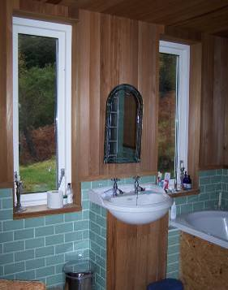
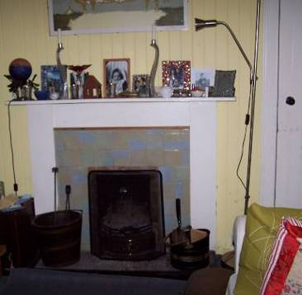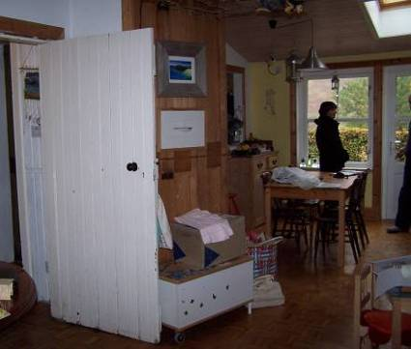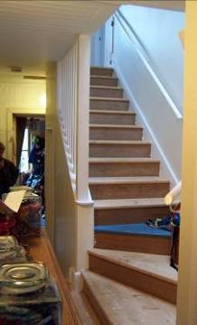
Figure 19, 20, 21 and 22 – interior views: fireplace in N room (far left), kitchen with new extension to E (centre left), stair to first floor (centre right), window arrangement in bathroom (far right).

The principal room to the south within the early cottage has been largely re-lined and refurbished with plaster board interiors and the woodwork has all been renewed but following the detail of the originals in the case of the architraves. The principal room has an applied dado rail throughout and the early fireplace in the centre of the south wall has a new hardwood fire surround. The late 1950s / early 1960s extension to the south is accessed by a slapping made at the time, an entrance at the east end of the south wall. This contains a door with a large glazed upper panel. The extension is subdivided internally by a north / south partition wall into two chambers. The one to the south-east had been the kitchen at that period and still contains sink units on the west side. It has a small window to the south and a larger window opening to the east which replaced an entrance. The north end of the partition wall retains the door of that date; this is of framed construction with tongue-and-grooved v-section boarding on the front. The room within is evidently a utility / scullery type room, lit by a single window in the south wall. The original window has been replaced with modern PVC.

The southern room within the original cottage had had an entrance towards the end of its north wall. This gave to a rear pantry chamber, originally behind the entrance vestibule. This room had evidently been removed at the expense of the installation of a new stair when the upper storey was added in the later 1960s. This stair arrangement itself has been replaced five years ago, also when the existing rear extension was added and the stair remodelled once again and extended somewhat further to the west. The rear extension is accessed via a small passage run through the rear of the original entrance vestibule. Within this, there are three steps up to the floor level of the rear extension which is terraced somewhat into the hill. This gives access to a small passage, at the east end of which, to the south, the flight to the upper storey rises. The passage extends further west, giving to a small closet area immediately to the south and then by means of entrances that set at 45° at the west end of the passage, to a bathroom to the south-west and a bedroom to the north-west. The upper flight of stairs rises in a straight flight up to the east, which culminates in a landing area lit by a single window in the east elevation. The landing provides access to the principal bedrooms to the north and south at first floor level. These are within the raised roof area added in the later 1960s. Each bedroom is lit by a broad window to the east and the bedroom interiors are substantially coombed to the west.

The stair landing extends to the west into the upper level of the rear extension. At the west end of the landing there are three entrances. The entrance to the south leads to a toilet, the one to the north to a shower and beyond into a large bedroom. Within this bedroom there are larger windows to the north and south and a pair of small windows in the west gable wall. The ceiling is lined out with 3 tongue-and-grooved v-section boarding. The ridge is formed by a substantial oak member. The ceiling follows the pitch of the roof, including to the north and south, the dormer projections. The walls are plasterboarded throughout.

